10/7/2020

Decisions

* Wheels - back and front
* Relative heights of the 3-wide and 5-wide chassis c-channels
  + Because the motor doesn’t fit right next to the edge of a c-channel
* Determined where the first bar of the H is going
* *Satvik - add decisions you made about the intake here cuz I don’t know what you decided*

*just write about all of that the end*

Day 2 of robotics, we started building the chassis itself and the rollers as well. Before we started all of this, we first discussed how we were going to build the chassis. Because we needed lots of space for the intake of the ball itself, we didn’t mushroom for the wheels and the motors. As we were discussing this, I found a youtube video of one of the reveals. In the video, it showed how instead of the motors being beside each other, it was stacked. I found this interesting and thought that it would be good for the robot. We decided that we will stick to the motors being side by side but if we needed more space, then we would go with the stacked motor. So as the three of the members started building the chassis, I decided that I would start working on the rollers. One issue that I came across was the spacing between the rollers and the chassis itself. I was trying to figure out how much spacing was needed and additionally, we needed to consider the size of the ball. One thing Joshua mentioned was that the rollers were not going to intake the ball but was going to push the ball up. So even though the size of the rollers were going to be smaller, it didn’t matter because the rubber band part was the only thing that was going to touch the ball. So with the plan that the rollers were going be 16cm wide (including c-channel), I started building the rollers. I had a little confusion of how to build it because of the placement of the rubber band but I asked one of the members from a different team on how to build it because he had more knowledge of it. With his info, I finished the first of three rollers. I started on the second one but didn’t have enough time so we started cleaning up. Overall, it was a productive time and we are going at a faster pace than we thought so everything is going smoothly.

10/14 2020

Today’s Robotics, we continued building chassis and connecting them. We struggled to dismember them and reattach them with batteries. We are almost done with the basic building of the chassis. We also planned for the intake.

10/16/20

In Robotics today, we straightened the loose 5 wide chassis by attaching two 5 wide at the end so that the middle 3 wide is perfectly perpendicular. We also discovered that the motors were sticking out the chassis in a slight angle, so we cut the inside to a slight curve so that the motors don’t stick out.

10/21/2020

Finished chassis and wiring. Wrote a quick user control program. Diagram of intake.

10/27 2020

Today in Robotics we rebuilt the whole chassis and reattached the wheels and the motors again.

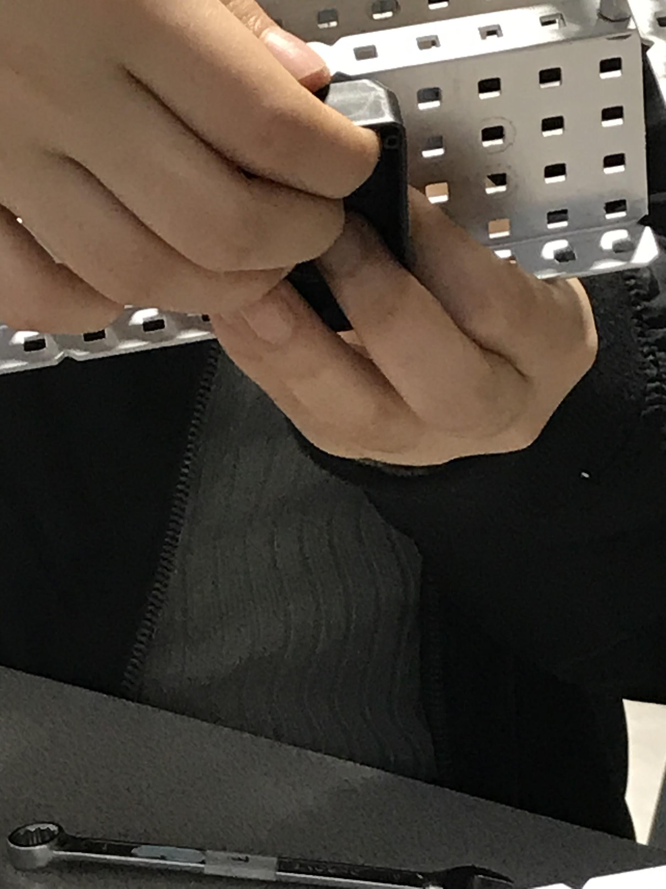

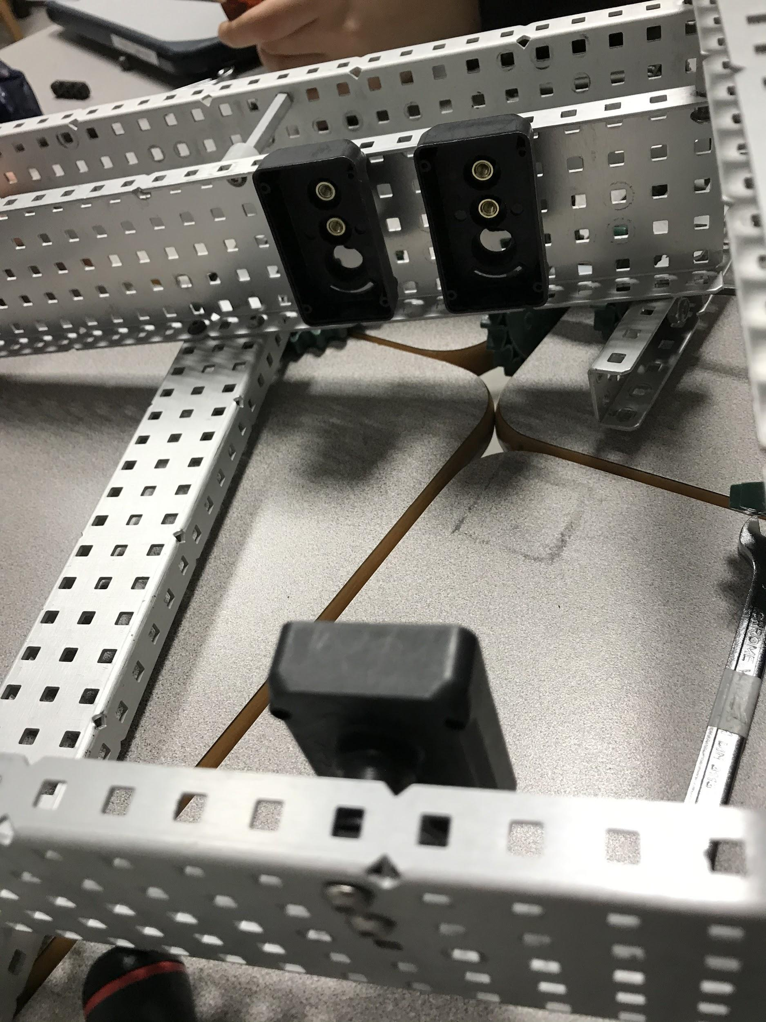

10/28 Today, I learned how to program the basic commands on C++code. First, we inserted the motor numbers in so that we will be able to control the wheels later with the controller. After commanding the wheels to spin 100 percent, (insert the code in colors) Everything needs to be in {parenthesis}.

I connected the brain to the computer so that it downloads the commands. Nextly, the controller was plugged in to the robot in order to control it wirelessly. We tested the robot and figured out that the right wheel was spinning backwards, so we had to reverse the wheel rotation in the code. Finally, the robot was ready to move inside the field. I was amazed at how simple commands could make the robots move. I am looking forward to programming!

We also worked on finishing up the chassis. Mainly we figured out spacing, attached the gears, the wheels and the motors. We will soon be ready to finish and attach the intake component.

11/4

-Rollers with metal pillow flats